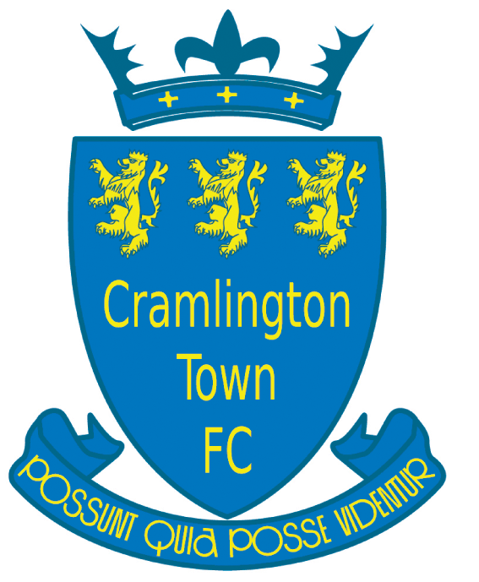
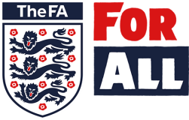
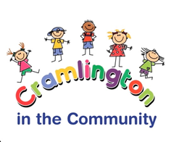
Membership form 2022 - 2023

Team Age Group |  | Team Name

Players Details
Players Full Name |  |  |  |  |  | D.O.B.
School Name |  |  |  | School Year  (From September 2022)
Parents/Guardians Details
Full Name |  |  |  | Relationship
Home Address
Email Address |  |  |  |  | Postcode
Mobile |  |  | D.O. B
Occupation
Payment holder Contact Details
Full Name |  |  |  | Relationship
Email |  |  | Mobile
Medical Details
Please indicate if the player has any medical conditions (e.g. asthma, allergies)
In the event that my son/daughter is injured while playing football and I cannot be contacted on the numbers provided, I hereby do/do not give my consent for my child to receive medical attention from a, first aider, doctor or hospital.
Parental Agreement
Please read carefully before signing
A: I/we give permission for my child’s photograph to be taken for use on our website and in the local press
B: In signing this document I/we agree to pay the Club Kit Bond of £30.00
C: In signing this document I/we agree to pay a one-off payment by 1 September 2022 or the option to pay 9 monthly subscriptions (August – April). THIS MUST BE DONE VIA LOVE ADMIN – link will be sent out and must be filled in to complete registration
D: I/we have been provided with club handbook and agree to abide by the Club rules and policies.
Parent Signature |  | Print Name |  |  |  |  | Date
Gift Aid declaration (past, present and future)
25p gift aid for every £1.00 given. Please treat as Gift Aid donations for all qualifying gifts of money made to Cramlington in the Community known as Cramlington Town FC, charitable status registration number: 1137605
Please tick all boxes that you wish to apply: Today ( ) in the past 4 years ( ) in the future ( )
I confirm that I have paid or will pay an amount of Income Tax and /or Capital Gains Tax for each tax year (6 April – 5 April) that is at least equal to the amount that all charities or community clubs (CASC’s) that I donate to will reclaim on my gifts for that year. Please notify the charity or CASC if you: want to cancel this declaration, change your name or home address, no longer pay sufficient rate and want to receive the additional tax relief due to you. You must include all your Gift Aid donations on your Self-Assessment tax return or ask HM Revenue and Customs to adjust your tax code.

